SEC Form 4

FORM 4

Check this box if no longer subject to Section 16. Form 4 or Form 5 obligations may continue. See Instruction 1(b).

UNITED STATES SECURITIES AND EXCHANGE COMMISSION
Washington, D.C. 20549
 |  | OMB APPROVAL
STATEMENT OF CHANGES IN BENEFICIAL OWNERSHIP
 |  | OMB Number: | 3235-0287
 |  | Estimated average burden
Filed pursuant to Section 16(a) of the Securities Exchange Act of 1934 |  | hours per response: | 0.5
or Section 30(h) of the Investment Company Act of 1940
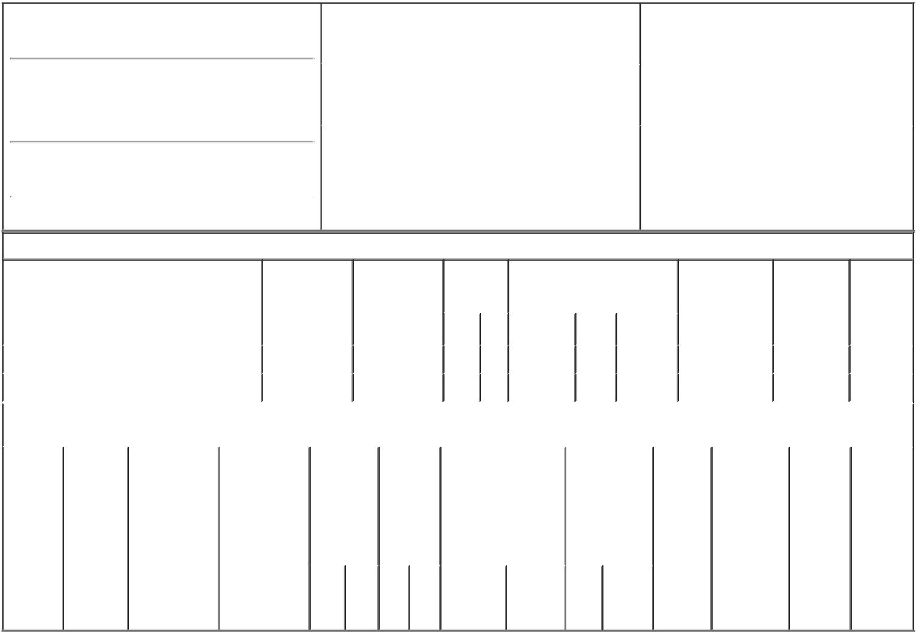

1. Name and Address of Reporting Person*
CROSBY MICHAEL

(Last) (First) (Middle)

C/O WORLD FUEL SERVICES CORPORATION 9800 N.W. 41ST STREET

(Street)
 | MIAMI | FL | 33178
 | (City) | (State) | (Zip)

2. |  | Issuer Name and Ticker or Trading Symbol |  | 5. Relationship of Reporting Person(s) to Issuer
 | WORLD FUEL SERVICES CORP [ INT ] |  |  | (Check all applicable)
 |  |  |  |  | Director | 10% Owner
 |  |  |  | X | Officer (give title | Other (specify
3. |  | Date of Earliest Transaction (Month/Day/Year) |  |  | below) | below)
 |  |  |  |  | EVP, Global Land
05/10/2018
4. |  | If Amendment, Date of Original Filed (Month/Day/Year) |  | 6. Individual or Joint/Group Filing (Check Applicable
Line)
X Form filed by One Reporting Person

Form filed by More than One Reporting
Person

Table I - Non-Derivative Securities Acquired, Disposed of, or Beneficially Owned

 | 1. Title of Security (Instr. 3) |  |  | 2. Transaction |  | 2A. Deemed |  | 3. | 4. Securities Acquired (A) or |  |  |  | 5. Amount of |  | 6. Ownership | 7. Nature
 |  |  |  | Date |  | Execution Date, |  | Transaction | Disposed Of (D) (Instr. 3, 4 and 5) |  |  |  | Securities |  | Form: Direct | of Indirect
 |  |  |  | (Month/Day/Year) |  | if any |  | Code (Instr. |  |  |  |  | Beneficially |  | (D) or Indirect | Beneficial
 |  |  |  |  |  | (Month/Day/Year) |  | 8) |  |  |  |  | Owned Following |  | (I) (Instr. 4) | Ownership
 |  |  |  |  |  |  |  |  |  |  |  |  | Reported |  |  | (Instr. 4)
 |  |  |  |  |  |  |  | Code V | Amount | (A) or | Price |  | Transaction(s)
 |  |  |  |  |  |  |  |  |  | (D) |  |  | (Instr. 3 and 4)
 | Common Stock |  |  | 05/10/2018 |  |  |  | A | 1,214 | A | $0.00 |  |  | 44,407 | D
 | Common Stock |  |  | 05/10/2018 |  |  |  | F | 533⁽¹⁾ | D | $22.81⁽²⁾ |  |  | 43,874 | D
 |  |  | Table II - Derivative Securities Acquired, Disposed of, or Beneficially Owned
 |  |  |  | (e.g., puts, calls, warrants, options, convertible securities)
 | 1. Title of | 2. | 3. Transaction | 3A. Deemed | 4. |  | 5. Number | 6. Date Exercisable and |  | 7. Title and |  | 8. Price of |  | 9. Number of | 10. | 11. Nature
 | Derivative | Conversion | Date | Execution Date, | Transaction |  | of | Expiration Date |  | Amount of |  | Derivative |  | derivative | Ownership | of Indirect
 | Security | or Exercise | (Month/Day/Year) | if any | Code (Instr. |  | Derivative | (Month/Day/Year) |  | Securities |  | Security |  | Securities | Form: | Beneficial
 | (Instr. 3) | Price of |  | (Month/Day/Year) | 8) |  | Securities |  |  | Underlying |  | (Instr. 5) |  | Beneficially | Direct (D) | Ownership
 |  | Derivative |  |  |  |  | Acquired |  |  | Derivative |  |  |  | Owned | or Indirect | (Instr. 4)
 |  | Security |  |  |  |  | (A) or |  |  | Security (Instr. 3 |  |  |  | Following | (I) (Instr. 4)
 |  |  |  |  |  |  | Disposed |  |  | and 4) |  |  |  | Reported
 |  |  |  |  |  |  | of (D) |  |  |  |  |  |  | Transaction(s)
 |  |  |  |  |  |  | (Instr. 3, 4 |  |  |  |  |  |  | (Instr. 4)
 |  |  |  |  |  |  | and 5)
 |  |  |  |  |  |  |  |  |  | Amount
 |  |  |  |  |  |  |  |  |  | or
 |  |  |  |  |  |  |  |  |  | Number
 |  |  |  |  |  |  |  | Date | Expiration | of
 |  |  |  |  | Code | V | (A) (D) | Exercisable | Date | Title Shares

Explanation of Responses:

- An aggregate of 972 shares of restricted stock and 1,214 restricted stock units held by the reporting person vested and settled on May 10, 2018. The issuer withheld the reported shares to cover the reporting person's tax liability associated with these shares of restricted stock and restricted stock units.

- The price shown is the closing price for the issuer's common stock on the NYSE on May 10, 2018.

Remarks:

/s/ Amy A. Quintana, |  |  | 05/14/2018
Attorney-in-fact
** Signature of Reporting Person |  |  | Date

Reminder: Report on a separate line for each class of securities beneficially owned directly or indirectly.

* If the form is filed by more than one reporting person, see Instruction 4 (b)(v).

- Intentional misstatements or omissions of facts constitute Federal Criminal Violations See 18 U.S.C. 1001 and 15 U.S.C. 78ff(a). Note: File three copies of this Form, one of which must be manually signed. If space is insufficient, see Instruction 6 for procedure.
Persons who respond to the collection of information contained in this form are not required to respond unless the form displays a currently valid OMB Number.

