SEC Form 4

FORM 4

Check this box if no longer subject to Section 16. Form 4 or Form 5 obligations may continue. See Instruction 1(b).

UNITED STATES SECURITIES AND EXCHANGE COMMISSION
Washington, D.C. 20549
 |  | OMB APPROVAL
STATEMENT OF CHANGES IN BENEFICIAL OWNERSHIP
 |  | OMB Number: | 3235-0287
 |  | Estimated average burden
Filed pursuant to Section 16(a) of the Securities Exchange Act of 1934 |  | hours per response: | 0.5
or Section 30(h) of the Investment Company Act of 1940
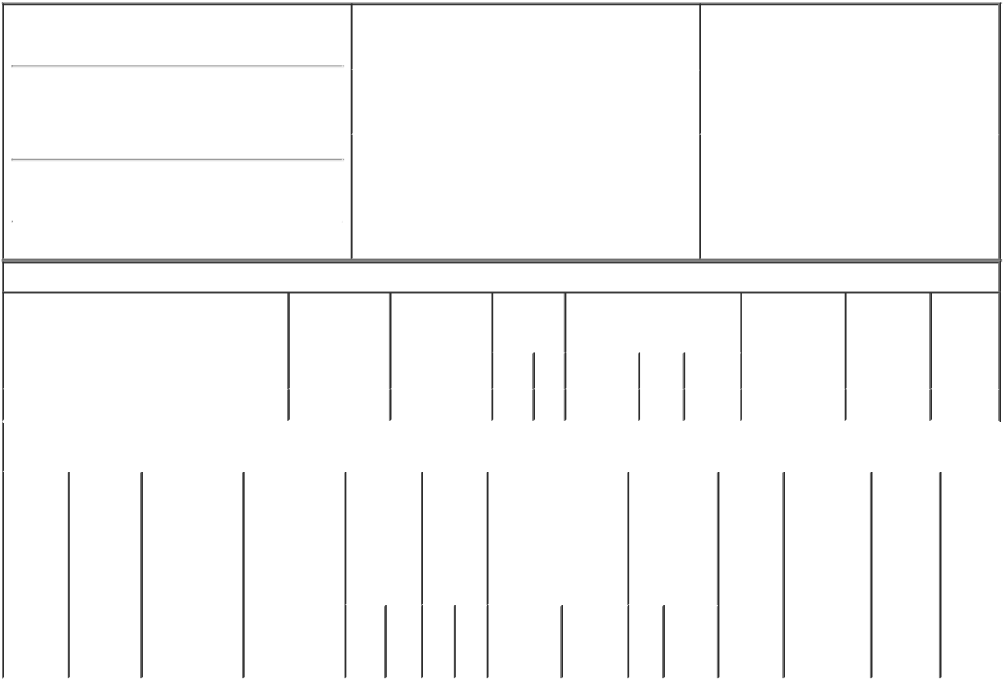

1. Name and Address of Reporting Person*
BAKSHI KEN

(Last) (First) (Middle)

C/O WORLD FUEL SERVICES CORPORATION 9800 N.W. 41ST STREET

(Street)
 | MIAMI | FL | 33178
 | (City) | (State) | (Zip)

2. |  | Issuer Name and Ticker or Trading Symbol |  | 5. | Relationship of Reporting Person(s) to Issuer
 | WORLD FUEL SERVICES CORP [ INT ] |  |  | (Check all applicable)
 |  |  |  |  | X Director | 10% Owner
 |  |  |  |  | Officer (give title | Other (specify
3. |  | Date of Earliest Transaction (Month/Day/Year)
 |  |  |  |  | below) | below)
05/21/2021
4. |  | If Amendment, Date of Original Filed (Month/Day/Year) |  | 6. | Individual or Joint/Group Filing (Check Applicable
Line)
X Form filed by One Reporting Person

Form filed by More than One Reporting
Person

Table I - Non-Derivative Securities Acquired, Disposed of, or Beneficially Owned

 | 1. Title of Security (Instr. 3) |  |  | 2. Transaction |  | 2A. Deemed |  | 3. | 4. Securities Acquired (A) or |  |  |  |  |  | 5. Amount of |  | 6. Ownership | 7. Nature
 |  |  |  | Date |  | Execution Date, |  | Transaction | Disposed Of (D) (Instr. 3, 4 and |  |  |  |  |  | Securities |  | Form: Direct | of Indirect
 |  |  |  | (Month/Day/Year) |  | if any |  | Code (Instr. | 5) |  |  |  |  |  | Beneficially |  | (D) or Indirect | Beneficial
 |  |  |  |  |  | (Month/Day/Year) |  | 8) |  |  |  |  |  |  | Owned Following |  | (I) (Instr. 4) | Ownership
 |  |  |  |  |  |  |  |  |  |  |  |  |  |  | Reported |  |  | (Instr. 4)
 |  |  |  |  |  |  |  | Code V | Amount | (A) or |  | Price |  |  | Transaction(s)
 |  |  |  |  |  |  |  |  |  | (D) |  |  |  |  | (Instr. 3 and 4)
 | Common Stock⁽¹⁾ |  |  | 05/21/2021 |  |  |  | A | 5,070⁽²⁾ | A |  | $0.00 |  |  | 49,695⁽³⁾ |  | D
 |  |  | Table II - Derivative Securities Acquired, Disposed of, or Beneficially Owned
 |  |  |  | (e.g., puts, calls, warrants, options, convertible securities)
 | 1. Title of | 2. | 3. Transaction | 3A. Deemed | 4. |  | 5. Number | 6. Date Exercisable and |  | 7. Title and |  |  |  | 8. Price of |  | 9. Number of 10. |  | 11. Nature
 | Derivative | Conversion | Date | Execution Date, | Transaction |  | of | Expiration Date |  | Amount of |  |  |  | Derivative |  | derivative | Ownership | of Indirect
 | Security | or Exercise | (Month/Day/Year) | if any | Code (Instr. |  | Derivative | (Month/Day/Year) |  | Securities |  |  |  | Security |  | Securities | Form: | Beneficial
 | (Instr. 3) | Price of |  | (Month/Day/Year) | 8) |  | Securities |  |  | Underlying |  |  |  | (Instr. 5) |  | Beneficially | Direct (D) | Ownership
 |  | Derivative |  |  |  |  | Acquired |  |  | Derivative |  |  |  |  |  | Owned | or Indirect | (Instr. 4)
 |  | Security |  |  |  |  | (A) or |  |  | Security (Instr. |  |  |  |  |  | Following | (I) (Instr. 4)
 |  |  |  |  |  |  | Disposed |  |  | 3 and 4) |  |  |  |  |  | Reported
 |  |  |  |  |  |  | of (D) |  |  |  |  |  |  |  |  | Transaction(s)
 |  |  |  |  |  |  | (Instr. 3, 4 |  |  |  |  |  |  |  |  | (Instr. 4)
 |  |  |  |  |  |  | and 5)
 |  |  |  |  |  |  |  |  |  |  | Amount
 |  |  |  |  |  |  |  |  |  |  | or
 |  |  |  |  |  |  |  |  |  |  | Number
 |  |  |  |  |  |  |  | Date | Expiration |  | of
 |  |  |  |  | Code | V | (A) (D) | Exercisable | Date | Title | Shares

Explanation of Responses:

- These shares were issued as a restricted stock unit grant to the reporting person by the issuer.

- The restricted stock units shall vest on the earlier of: (i) the day prior to the annual meeting of the shareholders of the issuer that next follows the grant date or (ii) the one-year anniversary of the grant date.

- Includes 202 stock units received by the reporting person in connection with deferred stock grants and dividends payable on such deferred stock grants under the issuer's Stock Deferral Plan for Non-Employee Directors.

Remarks:

/s/ Amy A. Quintana, |  |  | 05/25/2021
Attorney-in-fact
** Signature of Reporting Person |  |  | Date

Reminder: Report on a separate line for each class of securities beneficially owned directly or indirectly.

* If the form is filed by more than one reporting person, see Instruction 4 (b)(v).

- Intentional misstatements or omissions of facts constitute Federal Criminal Violations See 18 U.S.C. 1001 and 15 U.S.C. 78ff(a). Note: File three copies of this Form, one of which must be manually signed. If space is insufficient, see Instruction 6 for procedure.
Persons who respond to the collection of information contained in this form are not required to respond unless the form displays a currently valid OMB Number.

